*Florida International University*

*School of Computing and Information Sciences*

CIS 4911 Senior Project – **Software Engineering Focus**

TESt TEST Danae Icxe

**Requirements Document**

|  |  |
| --- | --- |
| Course: | CIS 4911 |
| System: | BOLO Flier Creator |
| Team: | Danae I. Perez Tillan  Icxe Vidal |
| Date: | 01/28/2015 |
| Instructor: | Masoud Sadjadi |
| Mentor: | Samuel Ceballos |

· Copyright and trademark notices, restrictions on copying or distributing the documentation, information for contacting the issuing organization (reader’s comments), warranties, contractual obligations or disclaimers, and general warnings and cautions.

· Abstract – one or two paragraphs giving a brief overview of the document.

· Table of Contents

1. Introduction

The Introduction provides a description about the system that will be built and the need of building such system. It will also provide a description of the expectations about the main system functionalities. Finally, it will provide a brief description of the rest of the document.

1.1. Problem Definition.

The Police Department Of the Pinecrest Village wants to develop an application that will assist first responder officers creating BOLO flyers when they arrive on the crime scene and allows them to upload them to a server; so that when a detective is assigned to the case, he is able to retrieve it from the system

1.2. Scope of system.

1.3. Terminology - Definitions, acronyms, and abbreviations.

|  |  |
| --- | --- |
| **Term** | **Definition** |
| Tier1 | This is a type of user. The (first responders) has access to Create, View, and Edit his/her own Bolo. |
| Tier2 | This is a type of user. This officer (supervisor) will have access to Tier1 permission plus edit, and delete a BOLO. |
| Administrator | Tier1 and Tier2 access |
| Registered User | A user that has created an account in the system |
| Bolo | Be on the lookout. The flier created for the officers to capture a suspect. |
|  |  |

1.4. Overview of document – brief explanation of what to expect in chapters 2 through 6.

2. Current System (limitations and problems) – either existing system or manual system that is being automated.

3. Project Plan (**This deliverable only**)

Introduce the project plan section (one or two paragraphs)

3.1. Project organization – assignment of roles for this deliverable.

3.2. Work breakdown – identification of milestones and deliverables (refer to project schedule in Appendix A and the diary in appendix B).

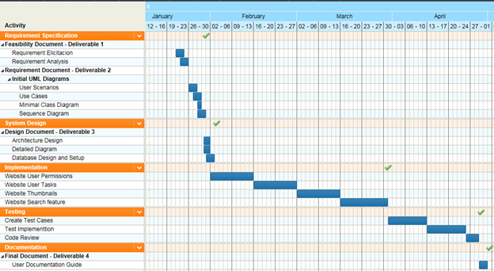

3.3. Cost Estimate – cost to develop the software system.

4. Proposed System Requirements

Introduce the chapter (one or two paragraphs)

4.1. Functional Requirements – describes high-level functionality

Use the following format:

*The system shall …*

For each functional requirement state the associated non-functional requirements, if any, for *Usability, Reliability, Performance,* and *Supportability*.

4.2. Analysis of System Requirements

Analysis models – contains the complete functional specification and is mainly for the designers and programmers. This section describes the diagrams in the Appendices B - D and validates the models against the use cases.

4.2.1. Scenarios

|  |  |
| --- | --- |
| **Scenario Id** | Bolo-001 |
| **Scenario Name** | Log In |
| **Actors** | Tier1, Tier2, Administrator |
| **Flow of Events** | A user log in to the system. The user enters his/her username and password and after correct validation of the information. The user accesses the Bolo Home Page. |

|  |  |
| --- | --- |
| **Scenario Id** | Bolo-002 |
| **Scenario Name** | Log Out |
| **Actors** | Registered User |
| **Flow of Events** | Registered user clicks log out on the User Home page |

|  |  |
| --- | --- |
| **Scenario Id** | Bolo-003 |
| **Scenario Name** | Forgot Password |
| **Actors** | Registered User |
| **Flow of Events** | A registered user clink on the “Forgot my password”link. |

|  |  |
| --- | --- |
| **Scenario Id** | Bolo-004 |
| **Scenario Name** | Edit Bolo |
| **Actors** | Registered User |
| **Flow of Events** | A Tier1 user logs in to the system and has the ability to edit their own Bolos.  Tier2 and Administrator can edit any Bolo created in the application. |

|  |  |
| --- | --- |
| **Scenario Id** | Bolo-005 |
| **Scenario Name** | Create Bolo |
| **Actors** | Registered User |
| **Flow of Events** | A user click on the Create Bolo button in order to open the Bolo template. The users will fill out the template with all the information need it. |

|  |  |
| --- | --- |
| **Scenario Id** | Bolo-006 |
| **Scenario Name** | Thumbnails Page |
| **Actors** | Registered User |
| **Flow of Events** | The registered user will see in the home page a representation of all the BOLOs created in the last 24 hours. Users can click on this these thumbnails to view the BOLO details. |

|  |  |
| --- | --- |
| **Scenario Id** | Bolo-007 |
| **Scenario Name** | Save bolo as pdf |
| **Actors** | Registered User |
| **Flow of Events** | The user will select the Bolo desired, then click in the link “Save as pdf”. All user will able to save it in their desktop computer. |

|  |  |
| --- | --- |
| **Scenario Id** | Bolo-008 |
| **Scenario Name** | Search Page |
| **Actors** | Registered User |
| **Flow of Events** | Users must have the ability of search BOLOs by Date and/or Categories. Once they enter the search criteria, they should also be given the option to sort the results by the date the BOLOs were created. |

|  |  |
| --- | --- |
| **Scenario Id** | Bolo-009 |
| **Scenario Name** | View Bolo History |
| **Actors** | Registered User |
| **Flow of Events** | Users are able to see all active BOLOs. Also, users can sort the those BOLOs by creation date and category. |

|  |  |
| --- | --- |
| **Scenario Id** | Bolo-010 |
| **Scenario Name** | Upload External Bolos |
| **Actors** | Tier2, Administrator |
| **Flow of Events** | Tier2 and Administrators users will have the ability to upload BOLOs they receive from outside agencies in PDF format. When uploading it, the application will ask them for the agency, date, and category of the Bolo. |

|  |  |
| --- | --- |
| **Scenario Id** | Bolo-011 |
| **Scenario Name** | 2 Step Verification |
| **Actors** | Registered User |
| **Flow of Events** | Registered users will have to go through a two factor authentication. When login in the website using the username and password, the application will ask for her/his security questions. |

4.2.2. Use case model

4.2.3. Static model e.g., object diagrams, class diagram

4.2.4. Dynamic model e.g., sequence diagrams or state machines

5. Glossary - define terms used in document, especially domain specific terms.

6. Appendix

6.1. Appendix A - Complete use cases

|  |  |
| --- | --- |
| Use Case ID | Bolo-001 |
| Description | Log In |
| Actor | Registered user |
| Pre-conditions | The user is on the Log in page of the system |
| Flow of Events | The user clicks on Log in link  The system will display to the user the new user form  The user will fill in all fields: username, password. |
| Alternate Flow | The user cancels the request by clicking on cancel or closing the browser. |
| Post-Conditions | The user is able to log in |
| Exceptions | The user forgot his/her password, so they will not be able to login in the system. |

|  |  |
| --- | --- |
| Use Case ID | Bolo-002 |
| Description | Log Out |
| Actor | Registered user |
| Pre-conditions | The user is Logged in the system |
| Flow of Events | The user clicks Log Out from the system. The system logs out the user from the application. |
| Alternate Flow |  |
| Post-Conditions | The system will not allowed the user to have access to the application without logging in again |
| Exceptions | The system fails logging out the user |

|  |  |
| --- | --- |
| Use Case ID | Bolo-003 |
| Description | Forgot Password |
| Actor | Registered user |
| Pre-conditions | The User has an account in the system  The User is on the Login page |
| Flow of Events | The User clicks on Forgot Password field  The user enters his email address  The User clicks Reset Password button  The system will send email with link to reset password  The User clicks link on email sent by the system  The User is redirected to the Reset Password form  The User enters new password and confirms the new password  The User clicks Accept button  The system updates the password in the database  The User is redirected to Login Page |
| Alternate Flow | The user cancel the request |
| Post-Conditions | The user will log in in the system with his new password |
| Exceptions | The new password does not match the confirmation password. |

|  |  |
| --- | --- |
| Use Case ID | Bolo-004 |
| Description | Edit Bolo |
| Actor | Registered user |
| Pre-conditions | The user is Logged in the system  The user is in the Bolo History page |
| Flow of Events | The user clicks on the Edit option  The user add or change information  The user click on Save button |
| Alternate Flow | User cancels the request by clicking any other page of the system or in the “Cancel” button. |
| Post-Conditions | The new Bolo information has been saved in the database |
| Exceptions | The user do not change any field in the Bolo form |

|  |  |
| --- | --- |
| Use Case ID | Bolo-005 |
| Description | Create Bolo |
| Actor | Registered user |
| Pre-conditions | The user is Logged in the system  The user is in the Home page |
| Flow of Events | The user clicks on the “Create Bolo” button. The system will display the Bolo form. |
| Alternate Flow | User cancels the request by clicking on the Cancel button at the end of the form. |
| Post-Conditions | The user is able to see the Bolo form to start fill out all the fields needed. |
| Exceptions | The Bolo form is not displayed. |

|  |  |
| --- | --- |
| Use Case ID | Bolo-006 |
| Description | Thumbnails Page |
| Actor | Registered user |
| Pre-conditions | The user is Logged in the system  The user is in the Home page |
| Flow of Events | The system display the most recent BOLOs created  The user click on any of the Bolo to see all description |
| Alternate Flow | The user click on any other link of the page. At that time he will be redirect to another page of the website. |
| Post-Conditions | The user is able to see the thumbnails of the most recent Bolos created in the last 24 hours. |
| Exceptions | The user do not see any Bolo in the Home page because in there are not Bolos created in the last 24 hours. |

|  |  |
| --- | --- |
| Use Case ID | Bolo-007 |
| Description | Save Bolo as pdf |
| Actor | Registered user |
| Pre-conditions | The user is Logged in the system  The user is in the History page |
| Flow of Events | The user select the Bolo desired  The user click on the “Save as” link  The system will display the browser box  The user find the place desired to save it on his/her computer  The user click on the Save option. |
| Alternate Flow | The user click on Cancel before saving the file |
| Post-Conditions | The Bolo is saved as a pdf file in the user’s computer. |
| Exceptions | The user does not select a Bolo to save |

|  |  |
| --- | --- |
| Use Case ID | Bolo-008 |
| Description | Search page |
| Actor | Registered user |
| Pre-conditions | The user is Logged in the system  The user is in the Search page |
| Flow of Events | The user select the filters need it  The user click on the search button  The system display the Bolos requested |
| Alternate Flow | The user click on any other link on the page |
| Post-Conditions | The system display the Bolos requested by the user using the filters selected. |
| Exceptions | The user does not select any filter when doing the search. |

|  |  |
| --- | --- |
| Use Case ID | Bolo-009 |
| Description | View Bolo History |
| Actor | Registered user |
| Pre-conditions | The user is Logged in the system  The user is in the History page |
| Flow of Events | The system display all active Bolos  The user can sort the Bolos by Date or Category  The user click on any of the Bolo  The system displays the Bolo’s information |
| Alternate Flow | The user navigate to other link on the page |
| Post-Conditions | The user will see the Bolo description for any of the Bolo created in the system. |
| Exceptions |  |

|  |  |
| --- | --- |
| Use Case ID | Bolo-010 |
| Description | Upload External BOLOs |
| Actor | Tier2 and Adminstrator |
| Pre-conditions | The user is Logged in the system  The user is in the Outside Agencies page |
| Flow of Events | The user click on the External Bolo link  The system will required to enter the Bolo’s agency, date, and category.  The user enter the fields required  The user click on the Upload Bolo button  The system will display the browse box  The user find the Bolo wanted  The user click on Save |
| Alternate Flow | The user click on any other link on the page  The user cancel the request |
| Post-Conditions | The external Bolo was uploaded succesfully into the website. |
| Exceptions | The user does not select a Bolo to upload |

|  |  |
| --- | --- |
| Use Case ID | Bolo-011 |
| Description | 2 Step Verification |
| Actor | Registered user |
| Pre-conditions | The user is in the Log in page |
| Flow of Events | The user clicks log in  The system will display the log in form (Login Page)  The User fills the username and password  The User clicks on Log In button  The system authenticates the credentials  The system will ask for the security question  The user enter the correct answer  The system validate that the user’s answer is correct  The system redirects the user to the User Home page |
| Alternate Flow | The user cancels the request by clicking on any other link or the user closes the browser |
| Post-Conditions | The user is already authenticated and logged into the system |
| Exceptions | The user does not remember his/her security question answer. |

|  |  |
| --- | --- |
| Use Case ID | Bolo-012 |
| Description | Edit BOLO |
| Actor | Tier2, Administrator, and Tier1 who created the BOLO |
| Pre-conditions | The user is in the Log in page  The user has found the BOLO he wants to edit and clicks on the “View” Button |
| Flow of Events | The case begins when the user clicks on the “Edit” button  The user is then able to edit the BOLO  The case ends when the user clicks on the “Save” button |
| Alternate Flow | The user clicks on the “Cancel” button and the changes are not saved to the database |
| Post-Conditions | The changes made to the BOLO were saved on the database |

6.2. Appendix B - Use case diagram using UML

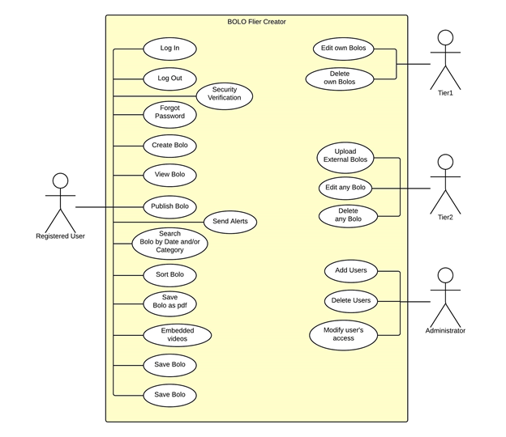

6.3. Appendix C - Static UML diagram

6.4. Appendix D - Dynamic UML diagrams

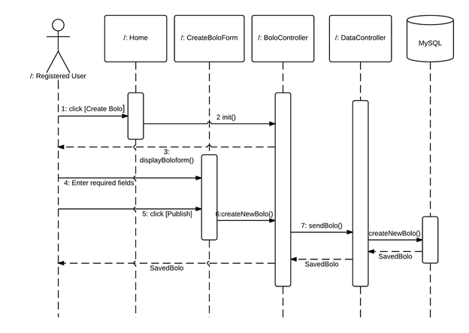

Create BOLO Sequence Diagram

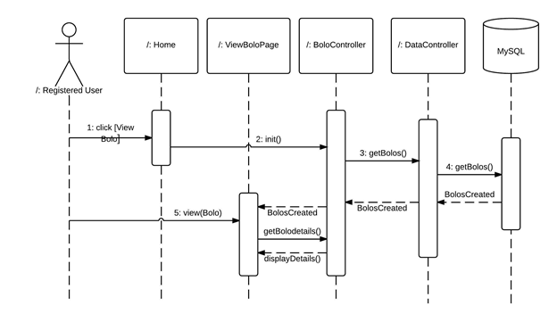

View BOLO Sequence Diagram

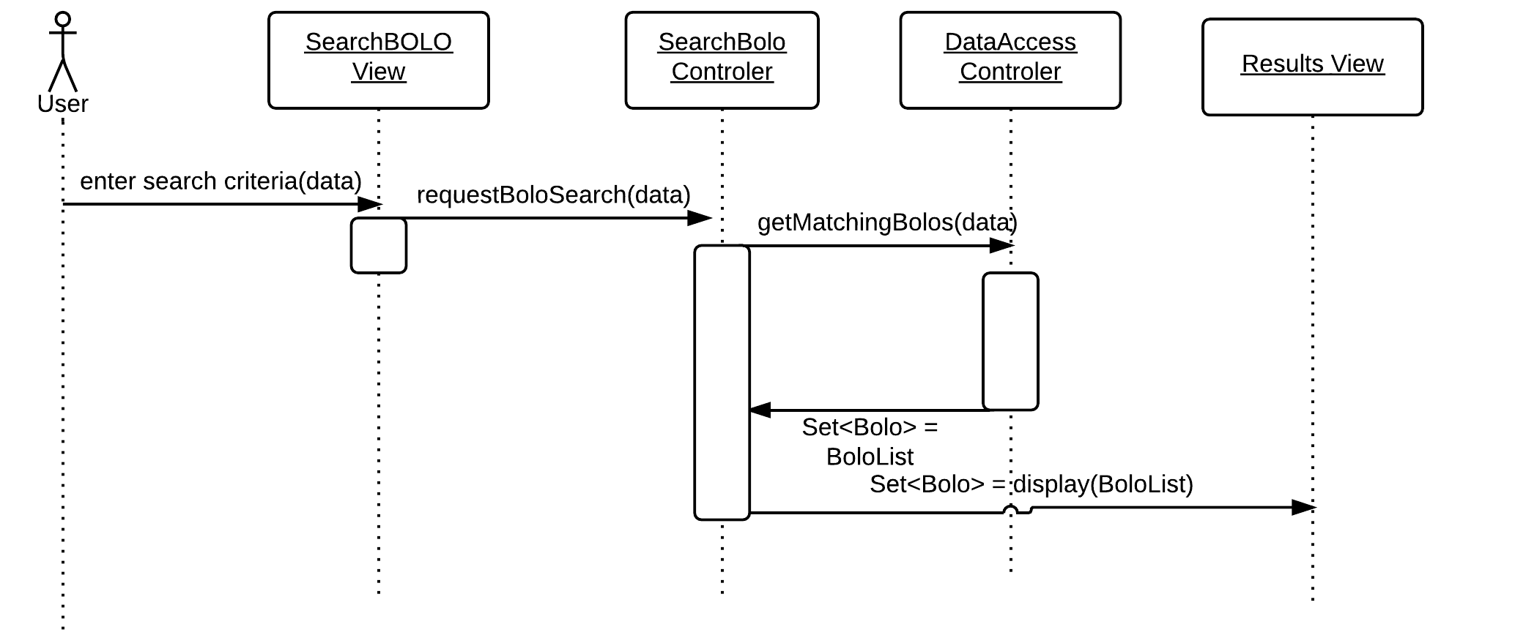Search BOLO Sequence Diagram

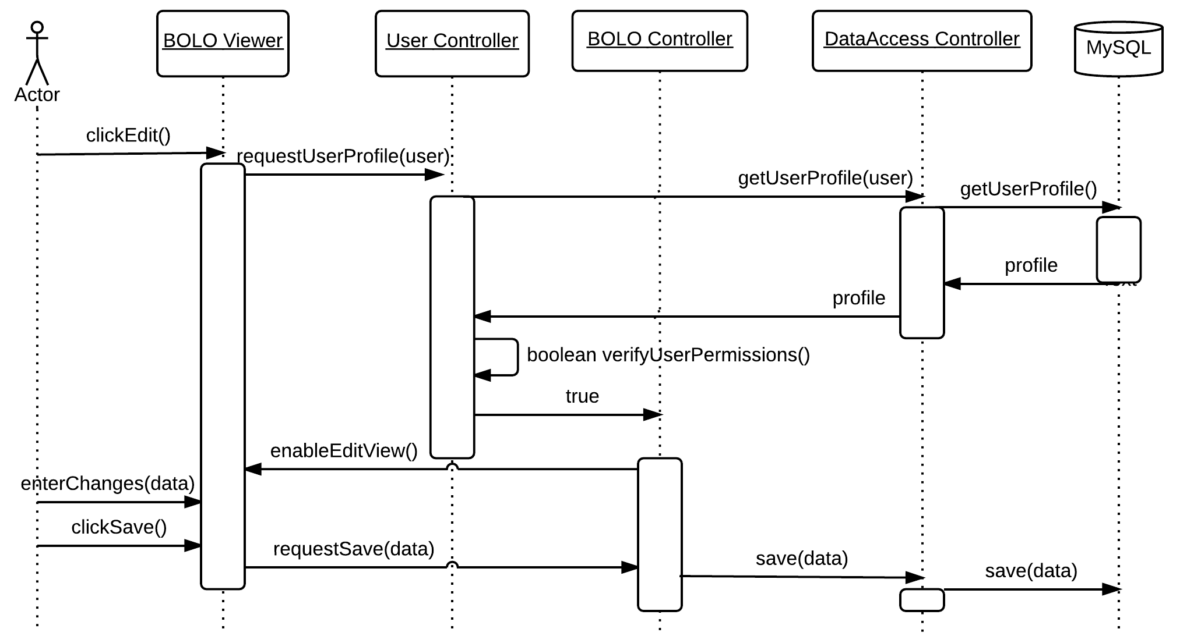Edit BOLO Sequence Diagram

6.5. Appendix E - User Interface designs.

6.6. Appendix F - Diary of meeting and tasks.

7. References

***Please email me the UML diagram in one file before the presentation.***